****Adventist University of CentralAfrica

PO Box 2461, Kigali Rwanda | [www.auca.ac.rw](http://www.auca.ac.rw) | [info@auca.ac.rw](mailto:info@auca.ac.rw)

**NAMES:BUNANI CYUSA PRINCE**

**ID: 24001**

**Charity System Documentation**

**Save Life by Donation System**

**1. Introduction**

**1.1 Overview**

The Charity System is a platform designed to facilitate the donation process, manage patients, and organize filter donations to save lives through community support.

**1.2 Purpose of the System**

The primary purpose of the system is to help patients who cannot afford their treatments.

**1.3 Target Audience**

* Donors
* Patients
* Administrators

**2. Getting Started**

**2.1 System Requirements**

To access the system, users need an internet connection and a compatible web browser.

**2.2 System's Structure**

Here is the erd of the system

[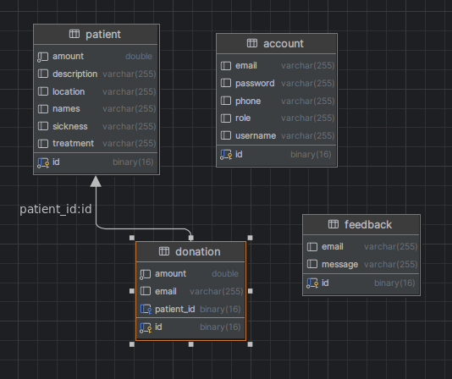](https://github.com/Neo-Joram/SLDonationSystem/blob/master/src/main/resources/static/images/erd.png)

**Homepage actions**

* Donor will view all we serve
* Donor can choose to donate one of them
* donor add's amount and email for submitting
* Donor can also send a feedback down on page
* [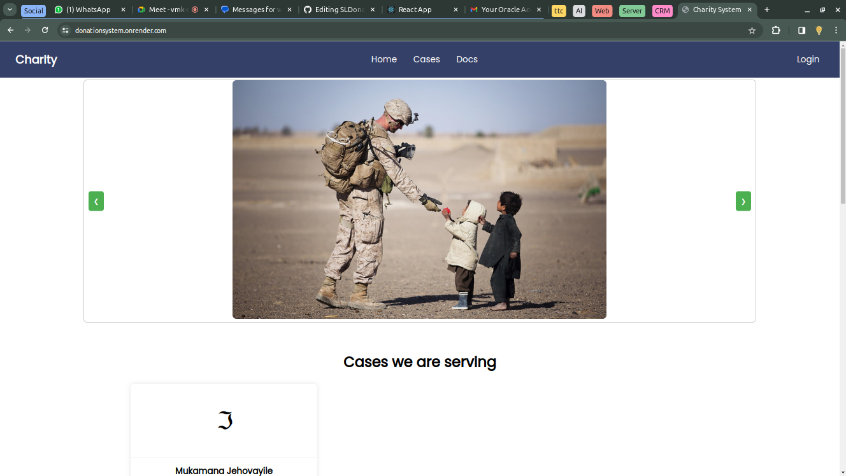](https://github.com/Neo-Joram/SLDonationSystem/blob/master/src/main/resources/static/images/img.png)
* 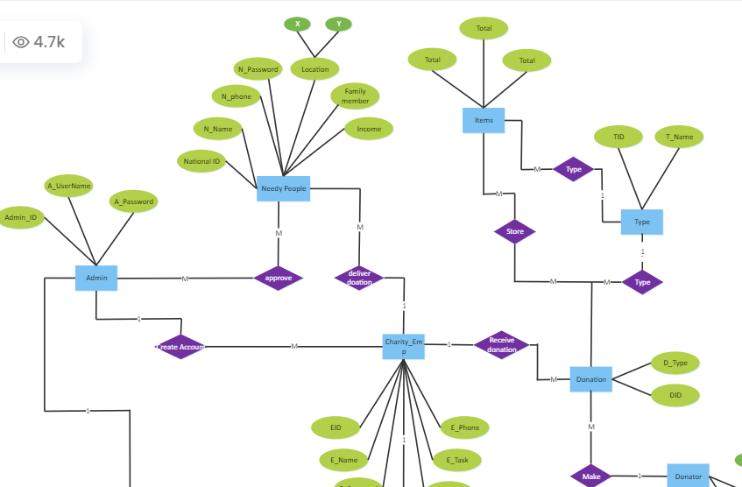
* To register or login: [localhost:9090](https://donationsystem.onrender.com/)**Registration rules**
* password must be more or equal to 5 characters
* user must use valid email
* user must add phone with 10 characters
* and all fields are required

[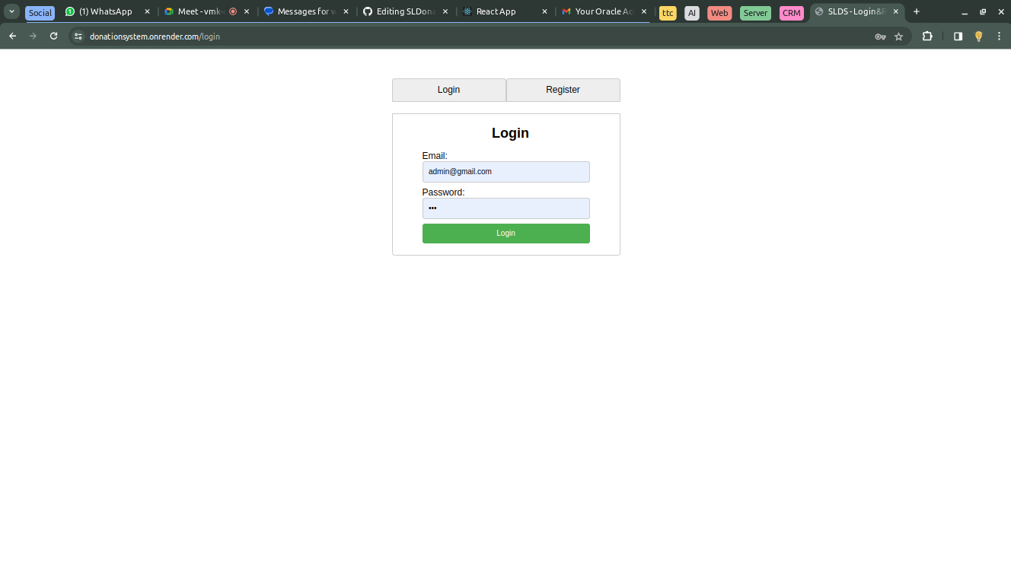](https://github.com/Neo-Joram/SLDonationSystem/blob/master/src/main/resources/static/images/login.png)

* After login, you’ll access the System’s dashboard as an admin.

**Admin is able to:**

* add, view, update and delete patients,
* view and delete Donations
* view and delete feedbacks
* [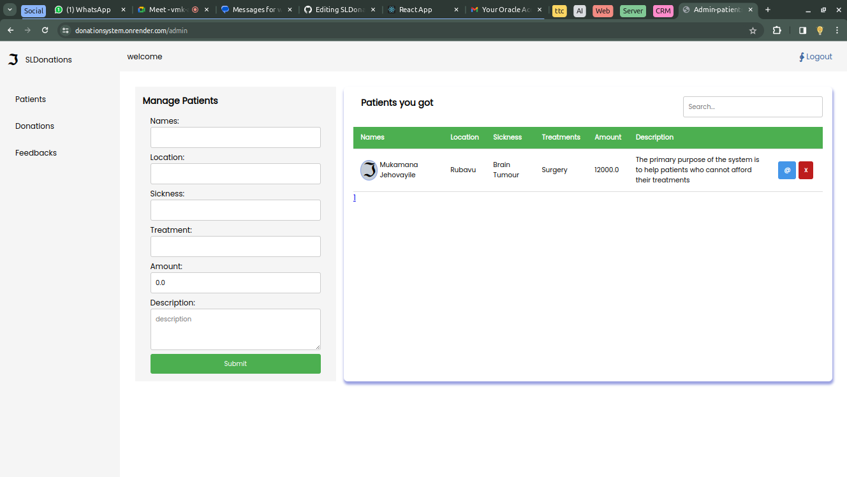](https://github.com/Neo-Joram/SLDonationSystem/blob/master/src/main/resources/static/images/patients.png)

**2.3 User Roles and Permissions**

* **Donors:** Can make donations and send feedback.
* **Administrators:** Have full access to system features, such as:
  + Create account
  + Login
  + CRUD on patients
  + Search & Filter
  + View Donations and delete

**3. Donations**

**3.1 Making a Donation**

1. Log in to your account.
2. Navigate to the "Donate" section.
3. Choose the donation type and amount.
4. Complete the payment process.

**3.2 Donation Process**

* User visits [localhost:9090](https://donationsystem.onrender.com/) and views all patients to donate.
* User clicks donate button to add a donation by simply entering email and amount.
* After a successful donation, the user will get an email with thanks.

**4. Feedback**

**4.1 Sending a Feedback**

* User visits [localhost:9090](https://donationsystem.onrender.com/) and scrolls to the footer to enter an email and feedback message.
* After a successful feedback, the user will be notified by email.

[](https://github.com/Neo-Joram/SLDonationSystem/blob/master/src/main/resources/static/images/img_1.png)

* Admin can view all feedbacks sent
* [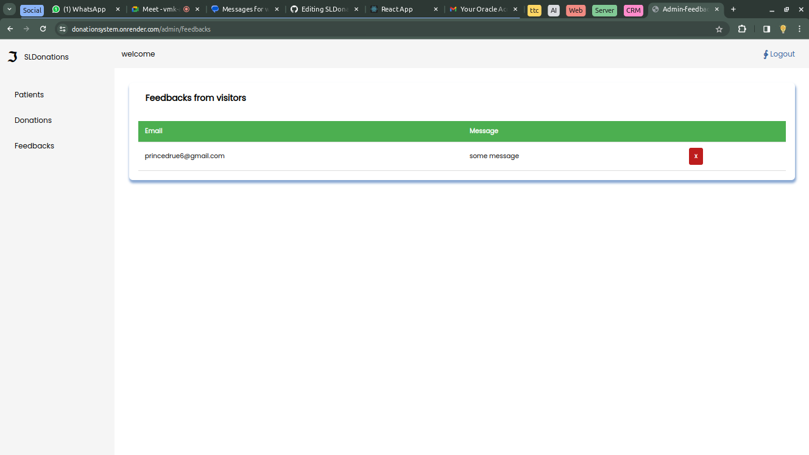](https://github.com/Neo-Joram/SLDonationSystem/blob/master/src/main/resources/static/images/feedbacks.png)